9. Connect all of the load cells to the board.

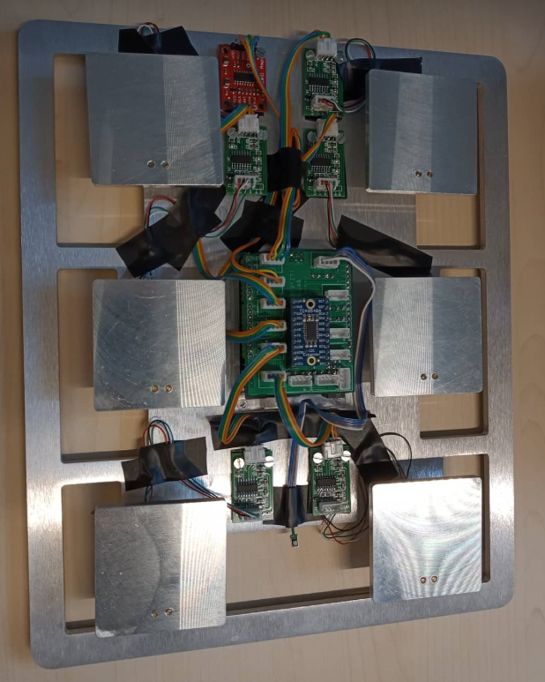

10. Put all of the six cups on the upper plates.

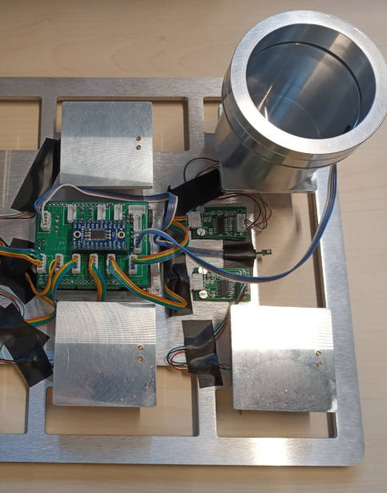

11. Connect all of the SHT85 sensors to the cups. \*\*WARNING\*\* All the sensors MUST be connected in that phase otherwise the sensors won’t be initialized afterwards.

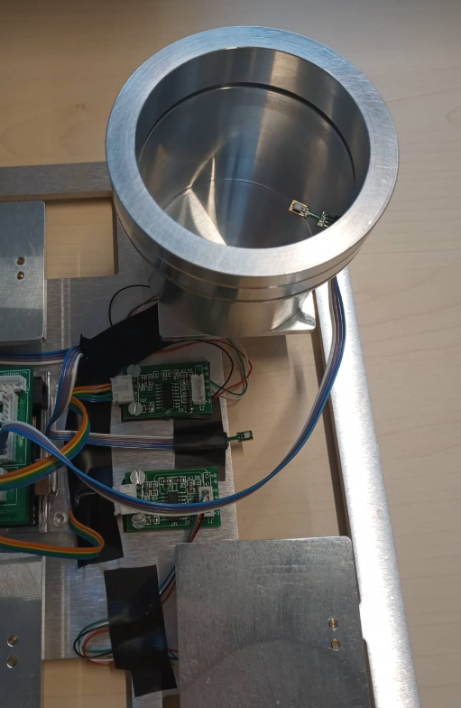

12. Connect the device to a laptop or a PC.

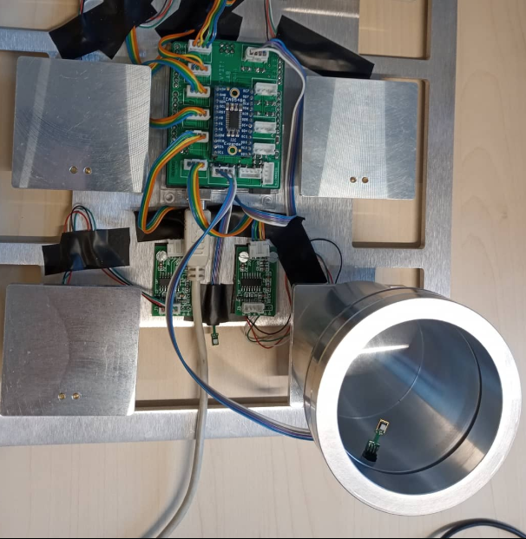

13. Open REVI’T software and click on connection section. Choose your port and after that put the same settings as the picture below.

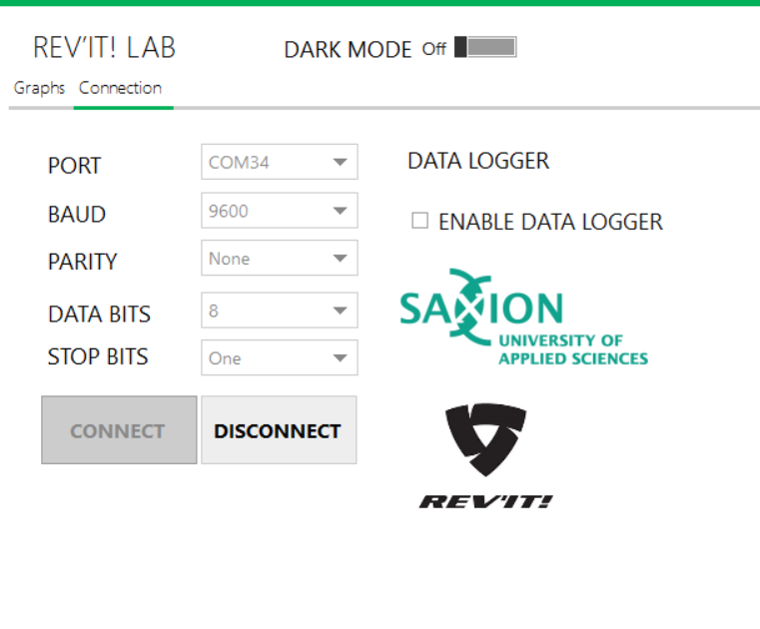

14. Click on graphs section.

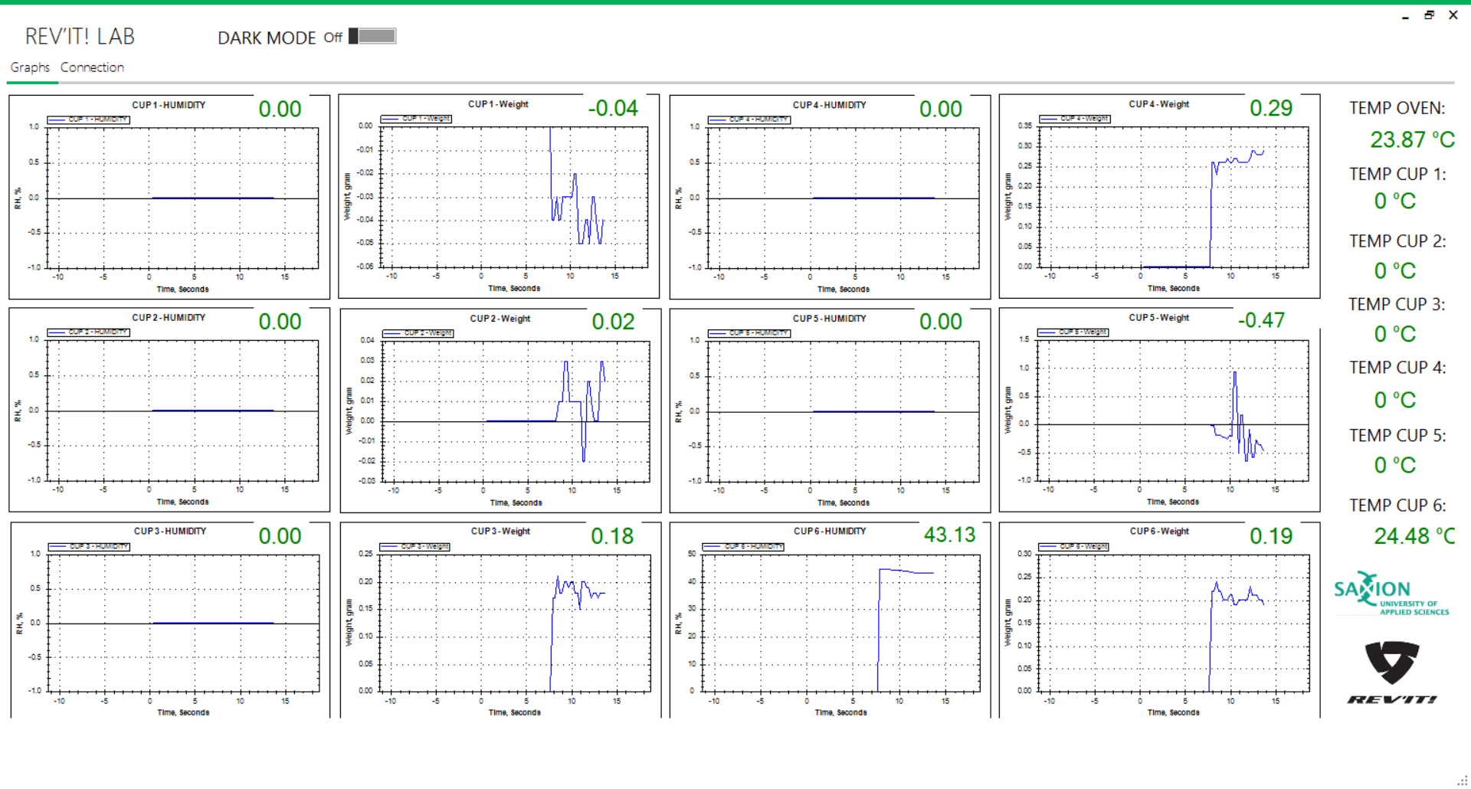

15. Take out the ring of the cups.

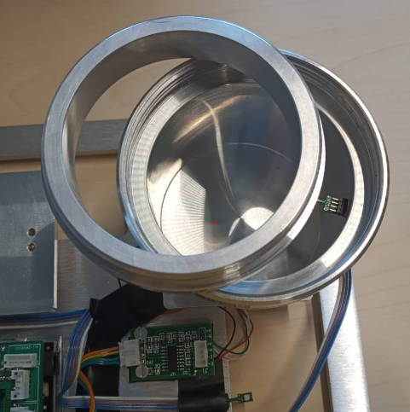

16. Put water in all of the cups.

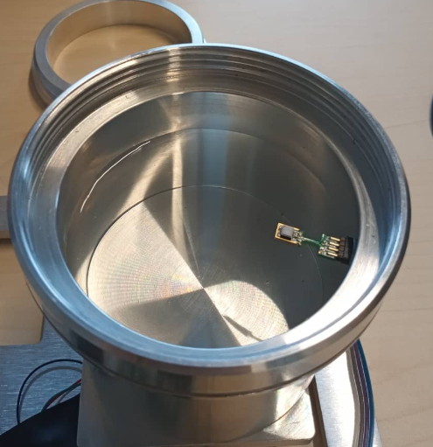

17. Put the first foam rings in the cups.

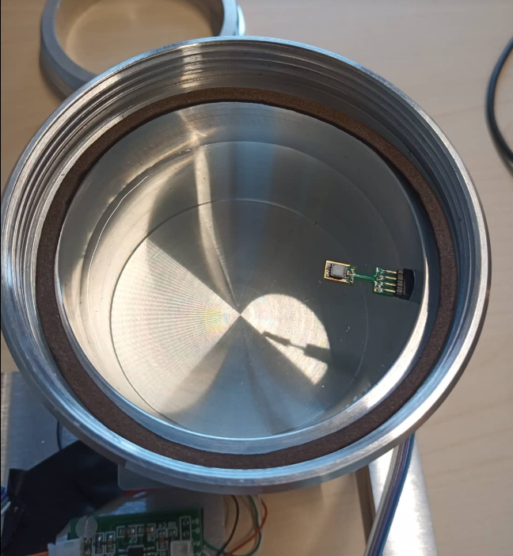

18. Put the textiles in the cups.

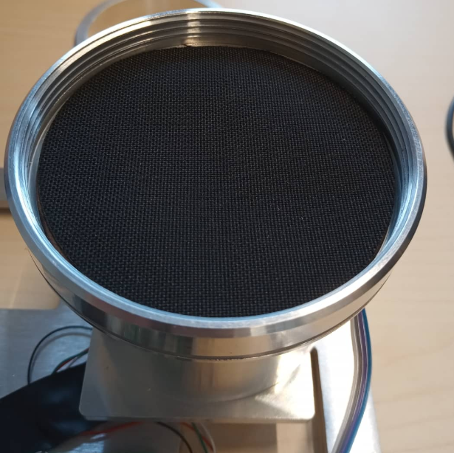

19. Put the second foam rings in the cups.

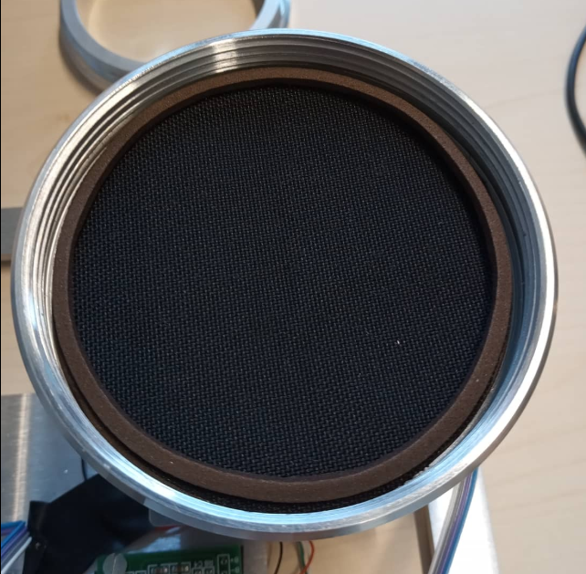

20. Put the plastics rings in the cups.

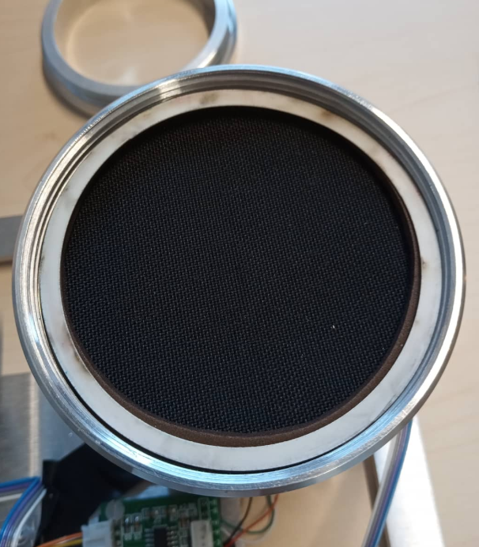

21. Put back the ring to the cups.

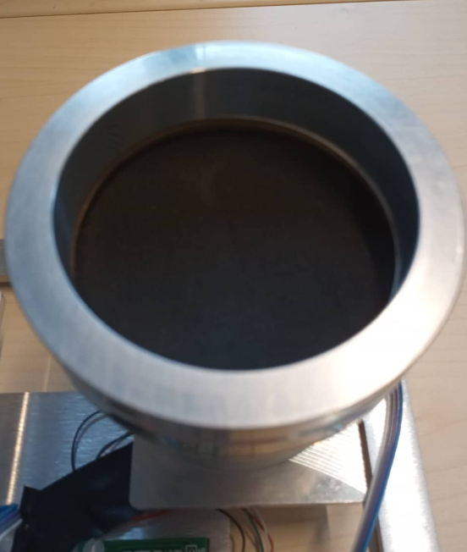

22. Check the graphs. For this was use only one cup and was cup 6.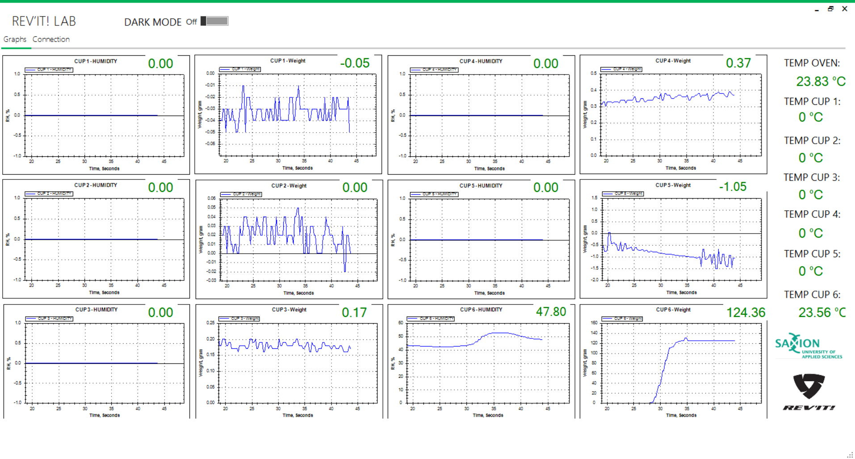

23. Open the connection section.

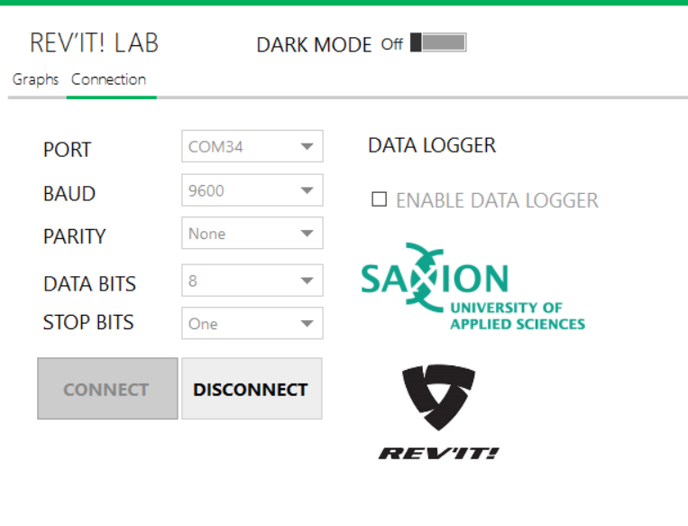

24. Click on Enable data logger.

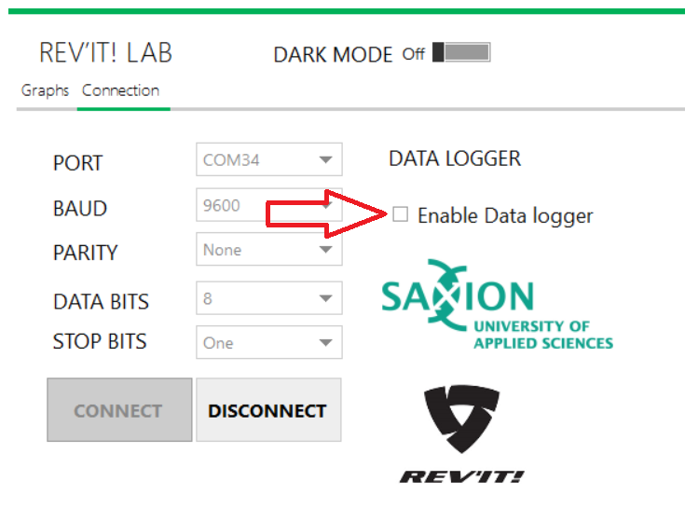

25. Window wills popup.

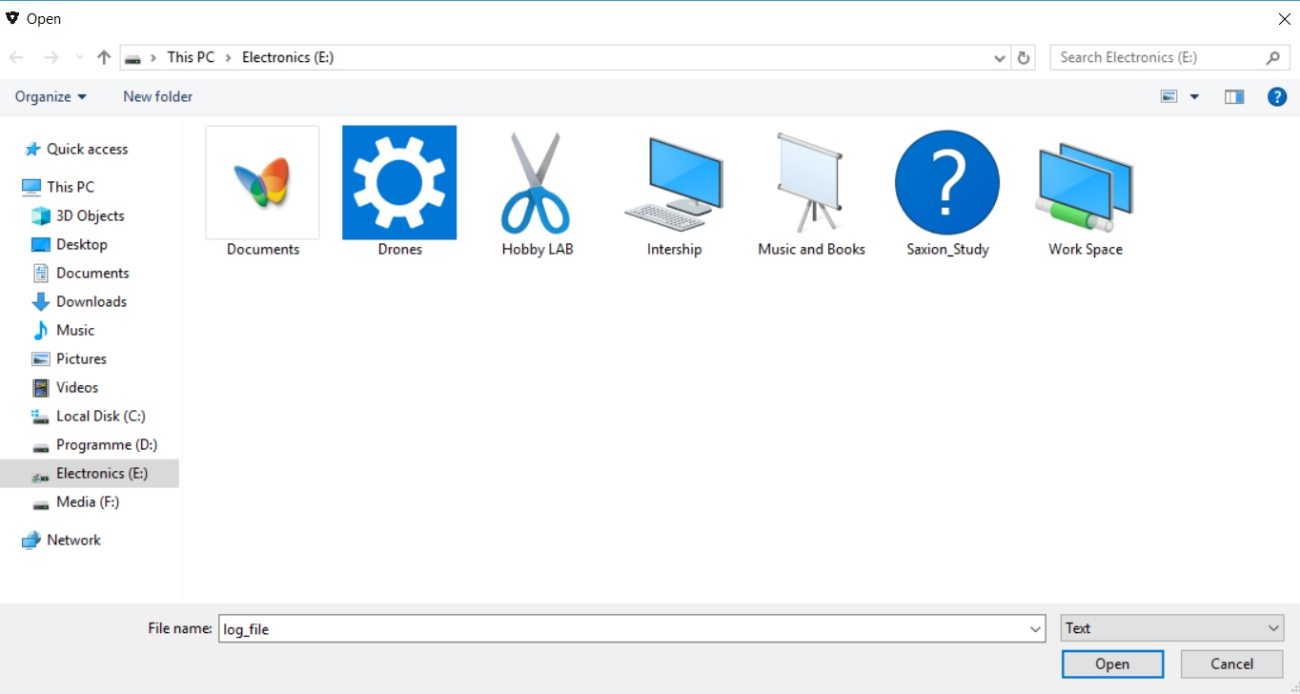

26. Make a new text file. Select it and click open.

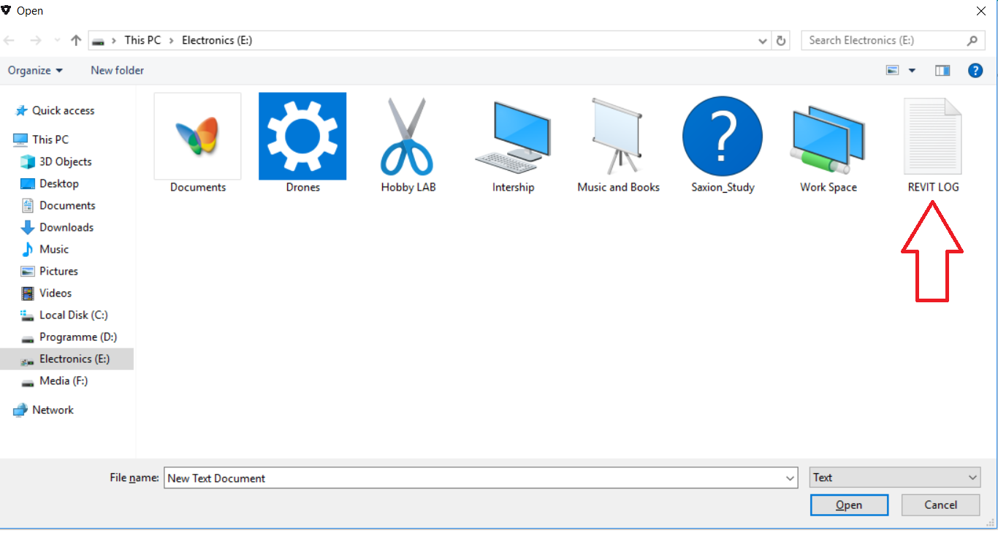

27. The name of your log file will appear on the screen. This means that logging of the data is started.

